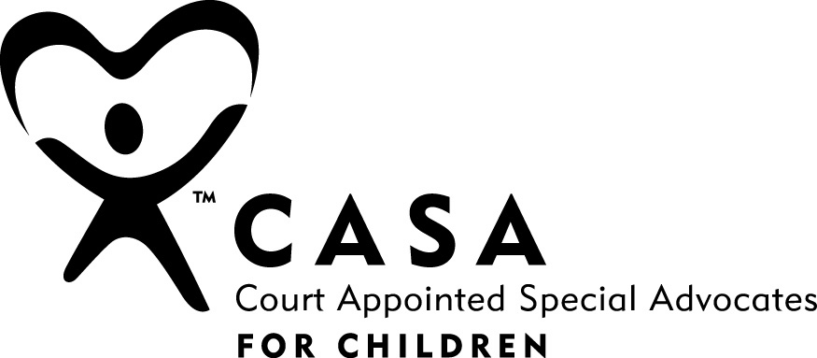 | CASA of Linn County, Inc.  2730 Pacific Blvd. SE, Suite 201,  PO Box 100, Albany OR 97321  P: 541.926.2651 ~ F: 541.924.3880  Admin@linncasa.org www.linncasa.org

Personal Information
Full Legal  Name | First Middle Last
Pronouns

Current Address
City |  | State |  | Zip
Contact Info | (Home) | (Work) |  | (Cell)
Email
Employment Status | Full-time Part-time Unemployed Retired
Current Employer |  |  |  | Position
May you be called at work? | Yes No
Emergency Contact Name & Relationship
Emergency Contact Phone number
Demographics
Race | African American Asian/Pacific Islander Caucasian  Multi-race Native American/Alaskan Unknown  Prefer not to answer __________
Ethnic Origin | Hispanic or Latino Non-Hispanic or Latino  Prefer not to answer __________
Marital Status | Divorced Married Separated Single  Prefer not to answer Widowed
Gender | Female Male Prefer not to answer __________

Education & Volunteer Experience
Education  (Circle highest completed) | High School:  9 10 11 12 |  |  |  | College:  1 2 3 4+ |  |  | Graduate:  1 2 3 4
Major(s) |  |  |  | Degree(s)
Do you speak or sign a language other than English? |  |  |  |  | Yes No  If yes, which language(s)?
List current and previous community activities/volunteer work:
What experience do you have working with children or young people? Please describe.
How did you learn of the CASA program?
Agency Corporation/Business Event Flyer Friend/Family Internet
Media Referral Agency Religious Org. Social Media Theta Other
Are you prepared to complete 35 hours of pre-service training and at least 5 hours of court observation? |  |  |  |  |  |  | Yes  No
Are you prepared to complete a minimum of 12 hours continuing education training annually? (Trainings are provided) |  |  |  |  |  |  | Yes  No
Is this a time in your life where you can commit to an average of 5-10 hours per month and two years of volunteer service? |  |  |  |  |  |  | Yes  No, please explain
Background Check Information
Are you 21 or older? | Yes No
Are you able to visit children at their home or out in the community at least once a month? |  |  |  |  | Yes No
Have you ever been convicted of a crime other than a traffic violation, or have criminal charge(s) pending? |  |  |  |  | Yes, please explain No
Charge(s):
Location:
Conviction date(s):
Have you had any personal or professional experience(s) involving:
ODHS Services or Child Welfare  Dependency or  Delinquency Court  Drug & Alcohol Services/Agencies |  |  | Foster Care  Citizen Review Board  Oregon Youth  Authority  Law enforcement |  |  | Mental Health Services/Agencies  Counseling  Other agencies offering  services to children,  adolescents, teens
Explain
Are you willing to do a criminal background check, and DMV record check? |  |  |  |  | Yes No
You are able and willing to maintain the highest standards of confidentiality? |  |  |  |  | Yes No
Technology Survey
Do you have regular access to a computer? |  |  |  |  | Yes No
If not, are you willing to come to the CASA office to work on your reports and case? |  |  |  |  | Yes No
Do you have internet access at home? |  |  |  |  | Yes No
Do you know how to attach documents to an email? |  |  |  |  | Yes No
Are you comfortable using the internet? |  |  |  |  | Yes No
Are you willing to participate in Court hearings? |  |  |  |  | Yes No
Are you comfortable using:  Microsoft Word  Zoom  Share Point  Outlook  WebEx |  | Yes No Willing to learn  Yes No Willing to learn  Yes No Willing to learn  Yes No Willing to learn  Yes No Willing to learn
Please write a statement describing why you would like to become an advocate for abused and neglected children. (Minimum 100 words)
References
Please list four (4) people who would be able to provide a knowledgeable reference for you. Do not list relatives. Please include at least one person who knows you in a professional capacity such as education, employer, pastor or community service personnel. The CASA office will contact each reference.
1.
Name

Address

City |  |  | State |  | Zip
Phone |  | Relationship
Email

2.
Name

Address

City |  |  | State |  | Zip
Phone |  | Relationship
Email

3.
Name

Address

City |  |  | State |  | Zip
Phone |  | Relationship
Email

4.
Name

Address

City |  |  | State |  | Zip
Phone |  | Relationship
Email

I,
Hereby affirm all of the answers provided on my volunteer application are true.

I understand CASA of Linn County, Inc., will investigate my background to determine my fitness as a potential volunteer.

I understand that the information requested in this application will be used only for the purpose of determining my suitability as a CASA volunteer. Further, I understand that completion of training does not guarantee that I will be accepted as a volunteer or assigned a case. If I have successfully completed the training and have met all other requirements, and it has been determined that I am a suitable volunteer, I understand that I will be expected to serve a minimum of two (2) years in the CASA program. If unforeseen circumstances prevent me from fulfilling this obligation, I will submit my written resignation to either the Advocate Supervisor assigned to me or the Program Manager with as much advance notice as possible. I am aware of the sensitive and confidential nature of the official documents, reports and other material I will examine in my capacity as a CASA volunteer. I will discuss these matters only with those persons directly involved in the case or who will be consulted for their professional knowledge and expertise.

I also understand that if for any reason it becomes apparent that my activities are contrary to the policies, goals and/or philosophy of CASA of Linn County program and their desire to provide quality services to abused and neglected children, my services as a CASA volunteer will be terminated.

Name (please print)
Signature
Date

CASA of Linn County Inc. is an equal-opportunity employer. CASA of Linn County Inc. reserves the right to disqualify any applicant who would not be appropriate for the CASA program. Any applicant found to have been convicted of either a felony or a misdemeanor involving a sex offense, child abuse or neglect, or related act that would pose risks to children or the CASA program’s credibility is not acceptable as a CASA Volunteer. CASA of Linn County Inc. further reserves the right to terminate any volunteer who is inappropriate for the program.

Internal use only
Date application received / Staff initials | Date Interview scheduled

Rev. 6/2023

